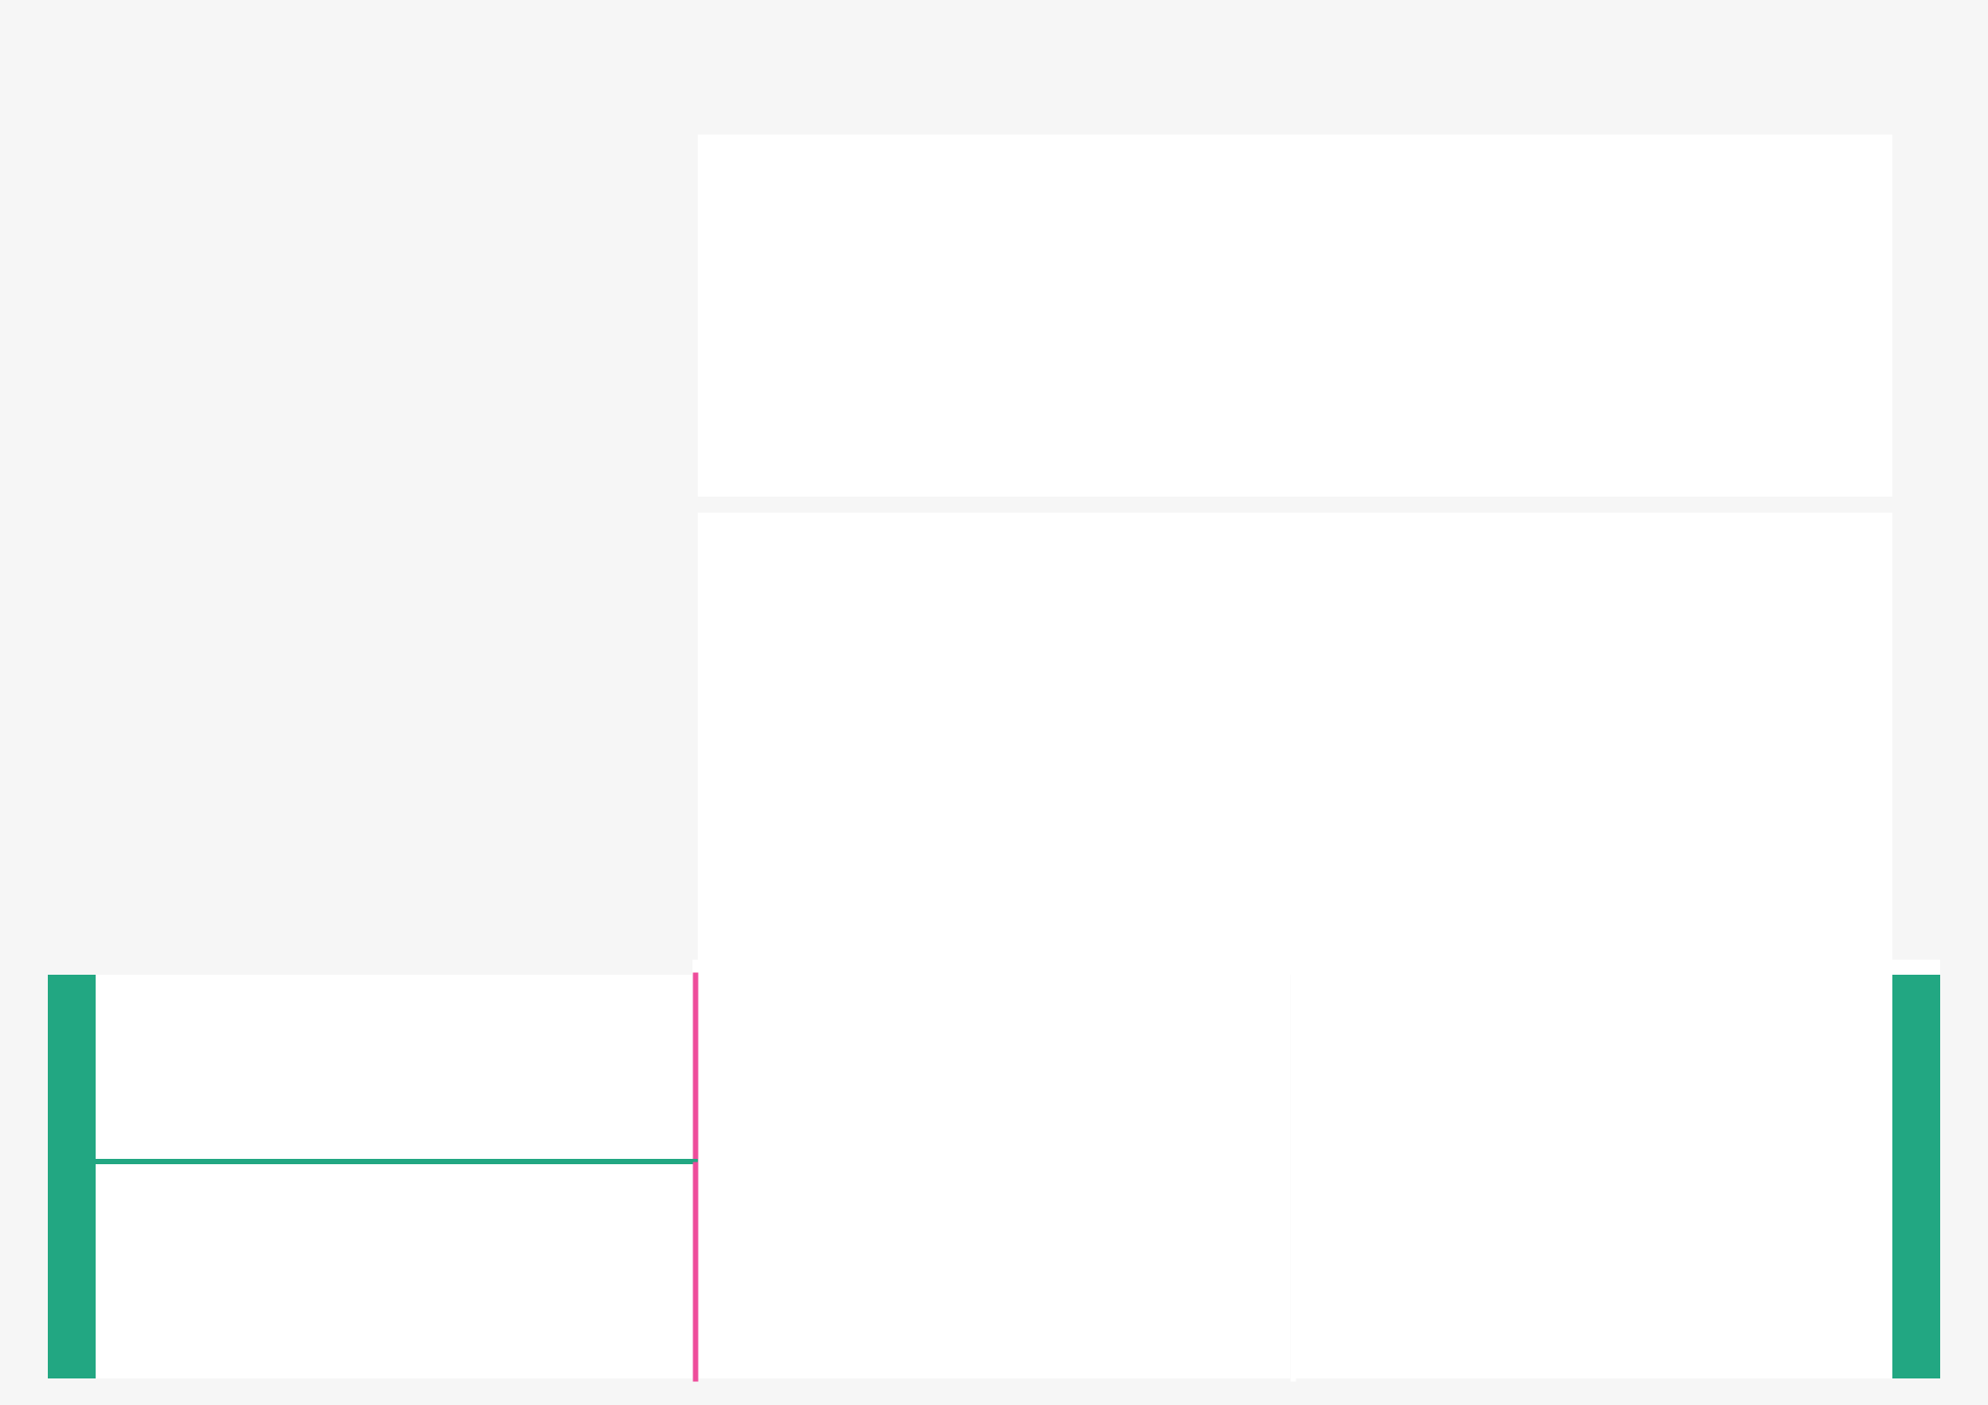  PROJECT DESIGN PHASE-I - SOLUTION FIT TEMPLATE | TEAM ID : PNT2022TMID24391- PLASMA DONOR APPLICATION

CC | 1. CUSTOMER SEGMENT(S) | CS |  | 6. CUSTOMER CONSTRAINTS | CC
into | ❖ Plasma donors should be in the age group of |  |  | ❖ Requires an active Internet Connection.
fit | 18-65 years. |  |  | ❖ Cannot Auto verify user genuineness.
fit | ❖ Donors should not be less than 45 kilograms.
Define CS,

 | 2. JOBS-TO-BE-DONE / PROBLEMS |  |  |  |  | J&P |  | 9. PROBLEM ROOT CAUSE |  |  |  | RC
BE, | ❖ The chances | of | more serious | problems |  |  |  | ❖ Donating plasma does not cause any side
BE, | happening during/after donating |  |  | plasma are |  |  |  | effects, but some donors experience
into
into | usually small | still, | drawing plasma |  | always |  |  | fatigue, | bruising, | bleeding | or
into | poses some risks.
tap |  |  |  |  |  |  |  | dehydration.
J&P, |  |  |  |  |  |  |  | ❖ Mismatched | transfusion | cause | acute
J&P, |  |  |  |  |  |  |  | kidney failure, anemia, lungs problems.
Focus on

5. AVAILABLE SOLUTIONS |  |  | AS |  | Explore
❖ Online application for plasma donation is |  |  |  |  | Explore
available but not user friendly. |  |  |  |  | AS,
❖ Plasma donor website in AWS | platform are |  |  |  | AS,
❖ Plasma donor website in AWS |  |  |  |  | differentiate
also available for finding plasma donors. |  |  |  |  | differentiate
7. BEHAVIOUR |  | BE |  |  | onFocus
❖ Directly Related : User-Friendly , Finds donors |  |  |  |  | onFocus
immediately. |  |  |  |  | J&P,
❖ Indirectly Associated : Require | High Internet |  |  |  | tap
speed. |  |  |  |  | tap
speed. |  |  |  |  | BE,into

Identify strong TR & EM

  - TRIGGERS
- Improve overall health and mood.

- Reduce Cholesterol Level and lower Blood Pressure

  - EMOTIONS: BEFORE / AFTER
- Before : Anxious, Fear, Frustrated.

- After : Reduces Stress and lowers developing serious diseases.

TR

EM

risk

of

10. YOUR SOLUTION SL

- The user interacts with the application.

- Registers by giving the details as a donor.

- The Database will have all the details and if a user posts a request then the concerned blood group donors will get notified about it.

8.CHANNELS of BEHAVIOUR CH

8.1 ONLINE

- Donors registers by giving the details. Patients posts a request and donors get notified

8.2 OFFLINE

- Application cannot be used offline.

Extractonline

&offline

CHof

BE

